Practice challenge
LO1 – Analyzing
Malamski,Dimitar D.S.
mitemalamata@gmail.com

Contents
Contents 1
Introduction 2
Sprints 2
Sprint 1 2
Evidence 1 - Project Proposal 2
Sprint 2 2
Evidence 1 - Dataset and target understanding 2
Evidence 2 - Data quality checks 4
Evidence 3 - Correlation analysis 5
Evidence 4 - Visual feature relationship analysis 8
Evidence 5 - Model comparison and interpretation 10

Introduction
This document presents the evidence for Learning Outcome 1 ( Analyzing ) in my Practice Challenge project - Student Dropout Prediction. The purpose of this document is to show how I demonstrated this learning outcome through the work completed during the project. The evidence is organized by sprints, with each section describing the activity, the result, and why it is relevant to the learning outcome.

Sprints

Sprint 1

Evidence 1 - Project Proposal
What this evidence is
In Sprint 1, I completed the project proposal for the Practice Challenge.
What I did
I defined the project idea, explored the problem domain of academic risk prediction, identified the stakeholder, and considered important risks such as dataset limitations, ethical concerns, bias, and data leakage.
Result
This proposal gave the project its initial direction and helped me evaluate whether the idea was feasible within the half-semester timeframe.
Why this is relevant to the Learning Outcome
This demonstrates analyzing because I first investigated the problem, clarified the goal of the project, and reflected on risks before moving into implementation.

Sprint 2

Evidence 1 - Dataset and target understanding
What this evidence is
This evidence shows how I started Sprint 2 by examining the dataset structure and understanding the prediction target before building any machine learning models.
What I did
I loaded the student dropout dataset and explored its main characteristics, including the number of rows and columns, the feature names, and the general types of variables included. I also reviewed the target variable and identified that the dataset originally contained three possible outcomes: Dropout, Enrolled, and Graduate. In addition, I grouped the features conceptually into demographic, academic, administrative, and macroeconomic categories in order to better understand the information available for analysis.
Result
This analysis gave me a clear understanding of the dataset composition and the prediction context. It helped me identify which variables were likely to be relevant for the problem and provided a foundation for the later exploratory analysis and modelling steps.
Why this is relevant to the Learning Outcome
This evidence demonstrates analyzing because I first investigated the structure and meaning of the dataset before moving to implementation. Understanding the available data and the prediction target was necessary in order to make justified analytical decisions in the later stages of the project.
Attached evidence
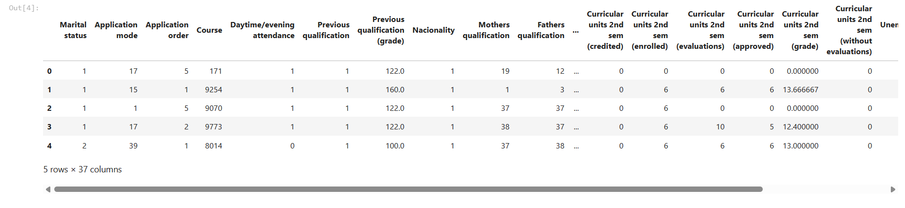
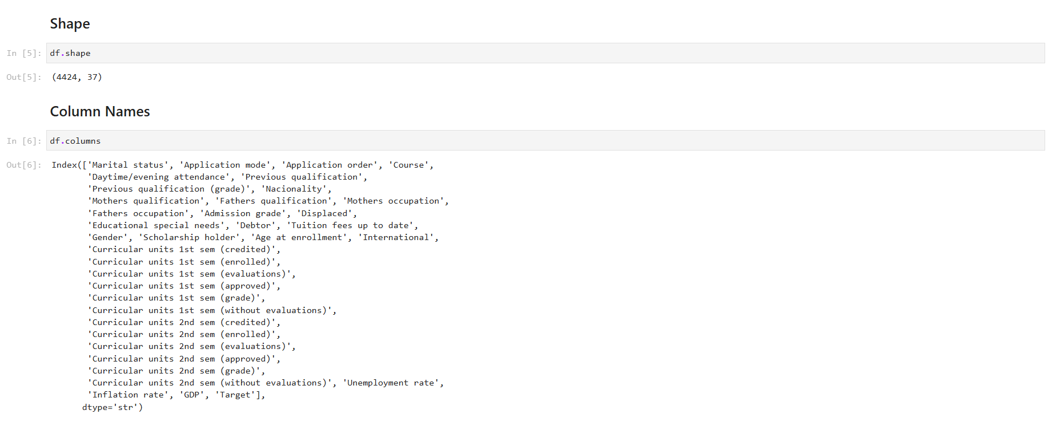
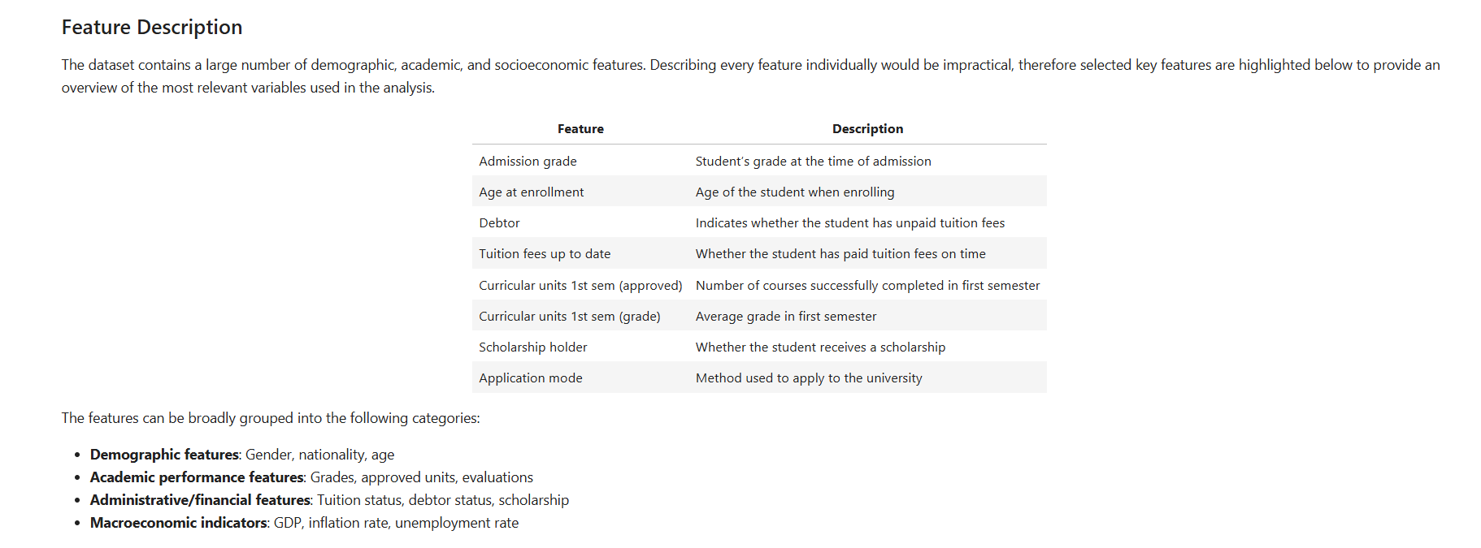
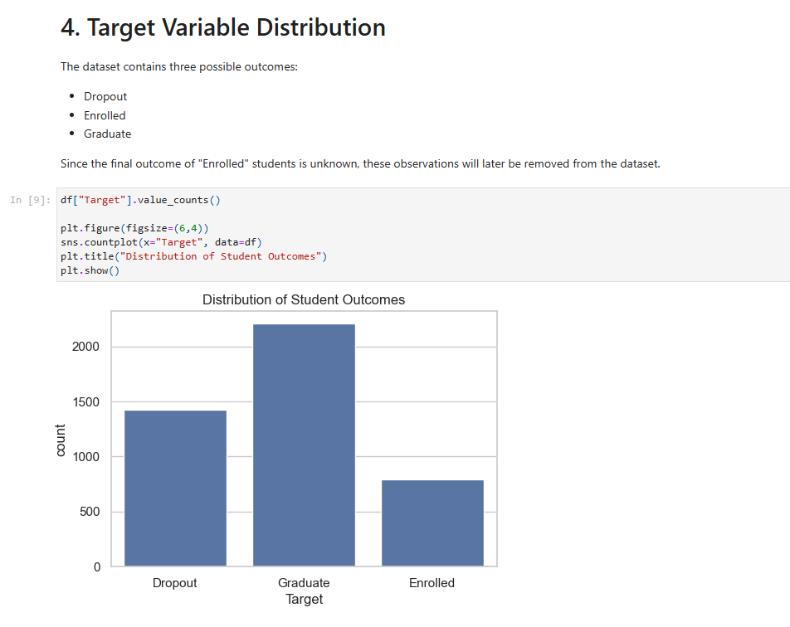

Evidence 2 - Data quality checks
What this evidence is
This evidence shows how I evaluated the quality of the dataset before continuing with the machine learning workflow.
What I did
I inspected the dataset for missing values and reviewed the data types of all variables. This allowed me to verify whether additional cleaning or imputation would be necessary before analysis. I also checked that the target variable and the predictor features were correctly represented in the dataset.
Result
The results showed that the dataset did not contain missing values, which meant that no imputation step was required. This confirmed that the dataset was suitable for further analysis and allowed me to proceed with a cleaner and more reliable preparation process.
Why this is relevant to the Learning Outcome
This demonstrates analyzing because I critically examined the quality and reliability of the dataset before using it for modelling. Rather than assuming the data was ready, I verified its condition and used that information to guide the next project steps.
Attached evidence
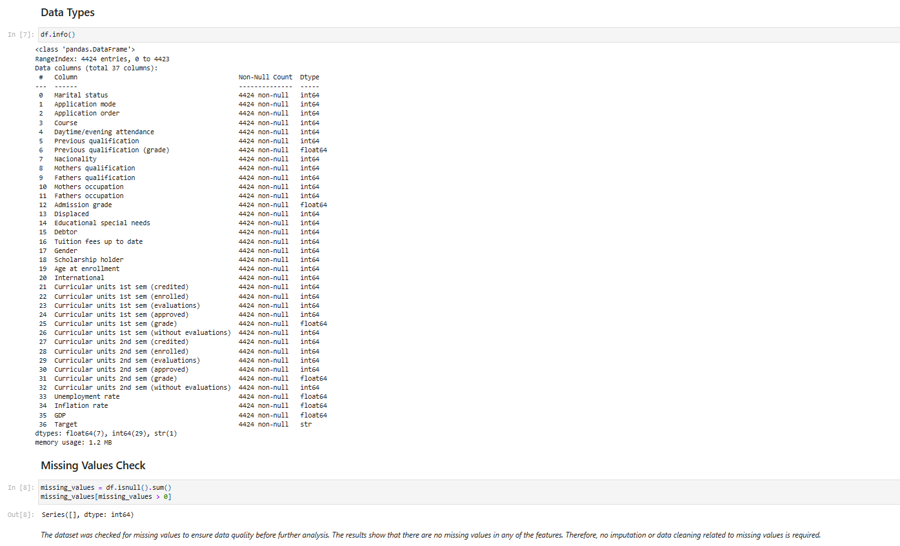

Evidence 3 - Correlation analysis
What this evidence is
This evidence shows how I analyzed the relationships between the predictors and the target variable in order to identify the most relevant patterns in the dataset.
What I did
I created a correlation heatmap and calculated the correlation between each feature and the target variable. I then interpreted which variables were most strongly associated with dropout risk. This analysis showed that academic performance variables, especially 1st and 2nd semester grades and approved curricular units, had the strongest relationships with the target. At the same time, demographic and macroeconomic variables generally showed weaker individual correlations.
Result
The analysis revealed that academic performance was the strongest signal for predicting dropout. It also helped me identify that several 2nd semester variables were highly predictive, which raised an important concern about possible data leakage in the later modelling stage.
Why this is relevant to the Learning Outcome
This evidence demonstrates analyzing because I explored the internal relationships in the dataset and used those findings to guide later decisions. The correlation analysis was not only descriptive but also informed the next preparation and feature selection steps.
Attached evidence
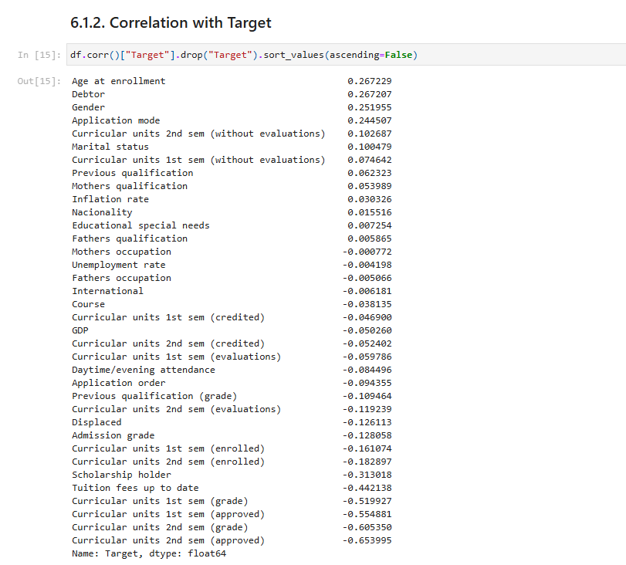
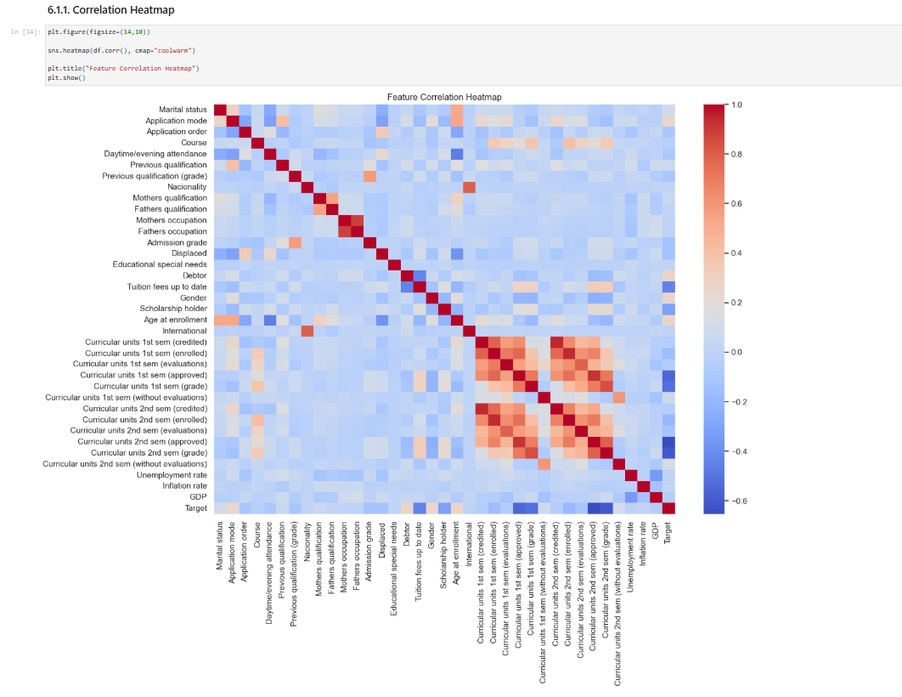

Evidence 4 - Visual feature relationship analysis
What this evidence is
This evidence shows how I used visual analysis to examine how selected features behaved across the dropout and graduate groups.
What I did
I created several visualizations to better understand the relationship between important features and the target variable. These included a boxplot for first-semester grades, a countplot for tuition payment status, and a histogram for age of enrollment. I then interpreted the patterns shown in these charts to understand how the characteristics of dropout students differed from those of graduate students.
Result
The visual analysis confirmed that lower first-semester grades were strongly associated with dropout, that students with unpaid tuition fees were more likely to leave their studies, and that older students were more represented in the dropout group. These results supported the findings from the earlier correlation analysis and provided deeper insight into the factors linked to student dropout.
Why this is relevant to the Learning Outcome
This demonstrates analyzing because I went beyond simple dataset inspection and interpreted patterns visually in order to understand how specific variables related to the outcome. This helped me build stronger evidence for the analytical decisions made later in the project.
Attached evidence
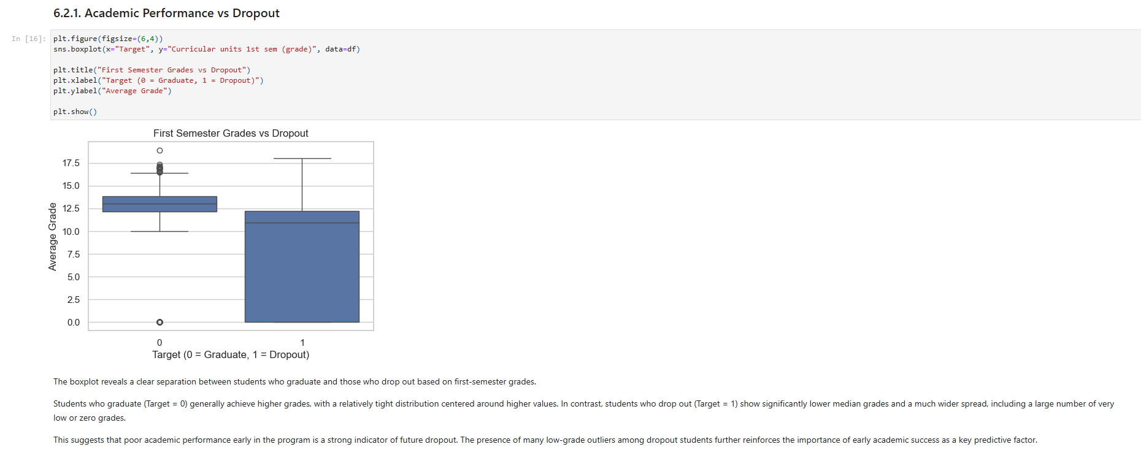
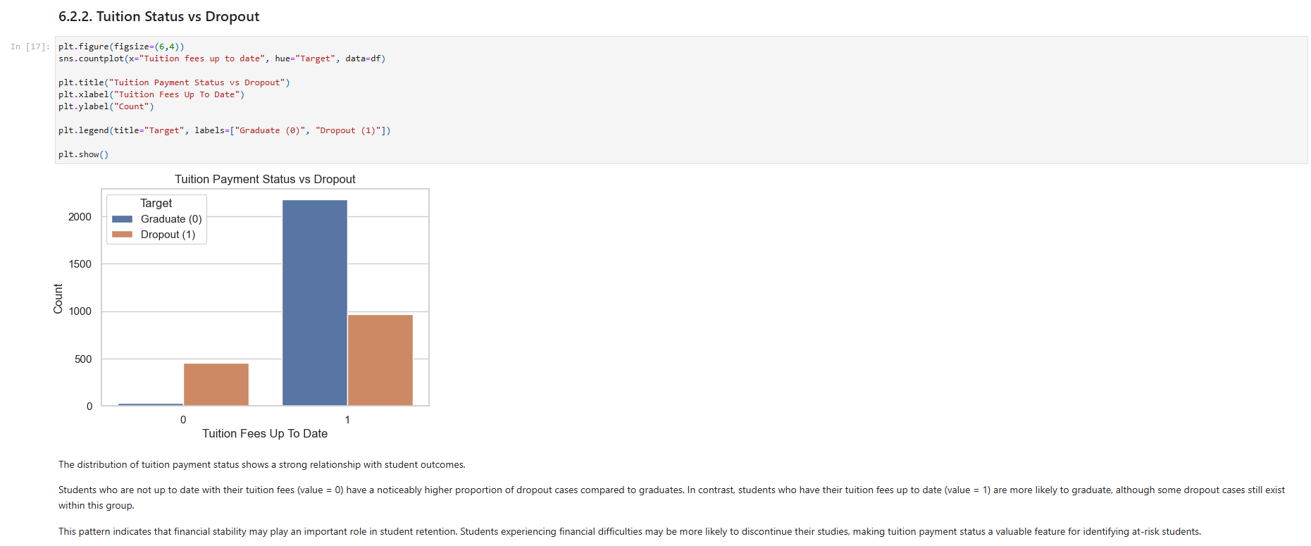
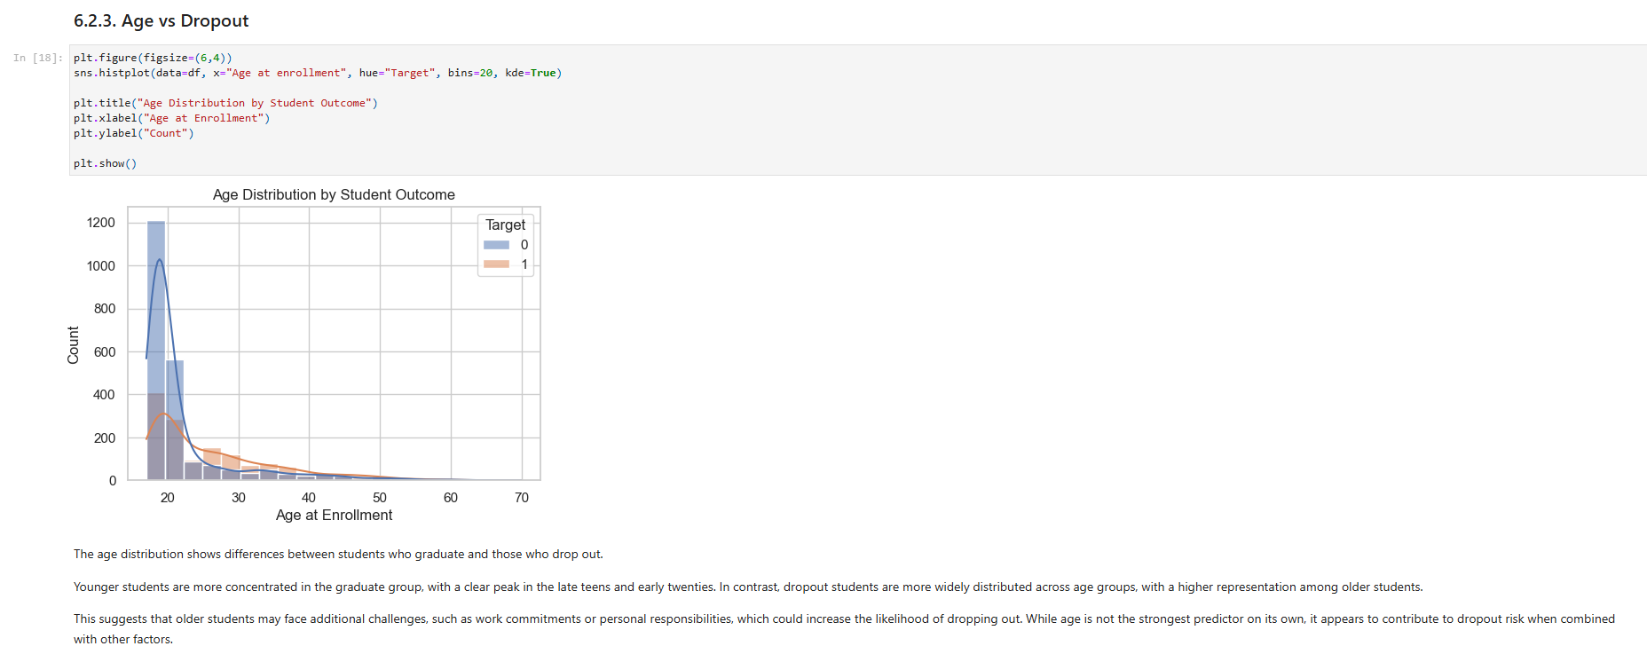

Evidence 5 - Model comparison and interpretation
What this evidence is
This evidence shows how I analyzed and compared the performance of multiple machine learning models in order to determine which approach was the most suitable for the prediction task.
What I did
I compared the results of Baseline Logistic Regression, Selected-Feature Logistic Regression, Random Forest, and Gradient Boosting using evaluation metrics such as accuracy, precision, recall, F1-score, and ROC-AUC. I then interpreted the differences between the models and considered what those differences meant in relation to the project goal of identifying students at risk of dropping out.
Result
The comparison showed that Random Forest achieved the highest F1-score, while Gradient Boosting achieved the highest ROC-AUC. It also showed that the Selected-Feature Logistic Regression model improved upon the baseline Logistic Regression model. This helped me understand the strengths and trade-offs of each model, rather than relying on a single score in isolation.
Why this is relevant to the Learning Outcome
This demonstrates analyzing because I critically interpreted the results of several experiments and used them to compare alternative solutions. The focus was not only on reporting performance values, but on understanding what those values meant for the project context.
Attached evidence
